TH & City District General Meeting - Monday 23rd February 2026
Theme: Identifying disability and discrimination in the workplace
Chair: Charlie (stepped in for Rae). Minutes: Pauline (Bow)
In person (12): Charlie (Bangabandhu), Rosie (Malmesbury / District sec), Danny (Arnhem Wharf), Jacob (TTCW), Pauline (Bow), Maria (Brick Lane), Sheila (SUTR), Teresa (CFGS), Amy (Morpeth), Sharon (Swanlea), Matt (Phoenix), Lucy (LEAP / District sec)
Online (2): Lisa (Cayley), Sam (Columbia nursery)
Apologies: Natasha (Oaklands / District sec), Rae (CFGS / President)
National ballot opens 28th February - Rosie
Expect to be sent a lot of reminders! It is essential that we get a really strong turnout. Just as a reminder of what is going on:
- The government proposes a three-year deal and an award of around 2% per year- probably less in the first year, as they want the rise to be back-loaded (higher awards in the second and third year)
- Inflation is currently 3.5% (CPIH). So, obviously, the government is proposing to cut teacher pay in real terms
- There is no additional funding for the pay award. “Most schools will need to implement plans to realise and sustain better value from existing spend” TLDR: Cuts!
- That is the reasoning for having a lower award in the first year- to give more schools more time to find cuts to make to fund the pay awards.
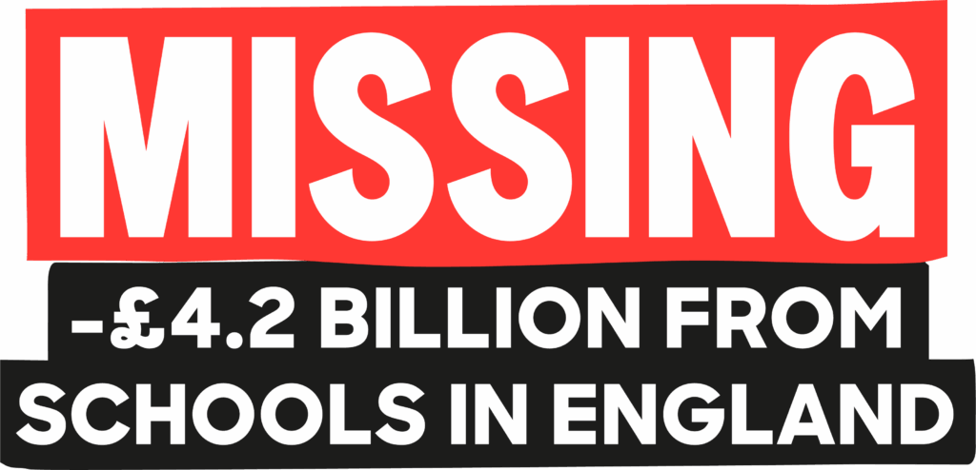
- “Affordability will be tightly constrained” in 2026/27 implying no more funding for schools.
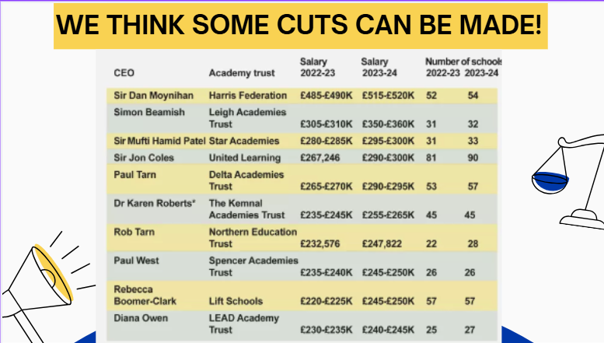
- Additionally, the STRB is reviewing the 1265 limit on teacher working hours, as it has been raised as a “significant and unnecessary burden on schools”
- Safeguarding of pay (where e.g. a TLR is removed but you keep the same pay for three years) is also under review
- Both ‘reviews’ could be a prelude to a threat to these elements of our working conditions. We must be prepared to resist this.
- For support staff: The NJC unions “reluctantly” accepted a pay award of 3.2%, backdated to April 2025.
- The NEU are not able to take part in national negotiations around support staff pay, but the NEU wants to work with the NJC unions to recruit more support staff- most are not in any union
The NEU campaigns for above-inflation pay awards to move towards restoration of pay lost since 2010, greater funding of schools to make up the £8.7bn deficit, and action on the workload crisis- teachers in the UK work more intensively and for longer hours than any other profession.
This award is unacceptable, and the national executive has announced an indicative national ballot for strike action, opening on February 28th

On 1265, the government notes “the risk of a change in this area being highly disruptive”. We should commit to making sure any threat to 1265 is defended with the disruptive threat of strike action.
London pulls up the rest of the nation so we need to do our best, not just for ourselves, but also for the other Districts out there where it’s harder to mobilise.
Stand Up To Racism – Amy
The threat of councils turning to Reform UK is real, and we need to be unified against this. Of course a Reform government would mean a complete overhaul of our terms and conditions. Remember Farage saying he’d go to war with the NEU?...
The NEU has shown time and again that it has an impact on election results, so let’s stay mobilised, organise meetings in schools especially on Thursday 5th, our workplace mobilisation day.
📸 Share your photo on this group and submit here for use in NEU social media https://national-education-union.boast.io/form/neu-together-mobilisation
Flexible working – Matt
Matt has worked really hard in drafting a clear document for headteachers to encourage them to get on board with flexible working. Reps can/should now have conversations with heads to follow up from this letter. A copy of the letter will be sent to workplace reps to be able to follow up.
Calais delegation in May – Amy
The delegation will be in May, date TBC. There will be some spaces, so do put yourself forward or talk to people you think might be interested in your school.
For context, delegations go a few times a year to Northern France to volunteer with refugees through an organisation called Roots.
Ongoing and upcoming local disputes – Lucy
Access Creative College: The union is now in talks with management, so hopefully there will be progress very soon. The strike dates booked are: 26th February, 2nd March, 4th March, 5th March, 10th March and 12th March, but strikes might be paused if talks are conclusive enough.
Brick Lane: Thanks to Maria’s incredible work, Brick Lane School is now ready to go on strike. They passed their formal ballot, and their first day of strike is 9th March at 7:30am. On 10th March the union will meet with management.
NEU Iftar event – Rosie/Pauline
See invitation email. There are still a few places left so book today if you’re interested!
Training: Disability and discrimination in the workplace - Rosie
See attached PowerPoint and Discrimination checklist

